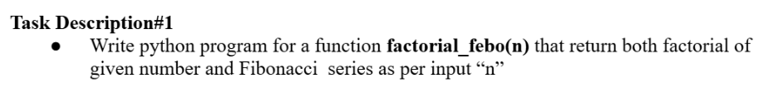
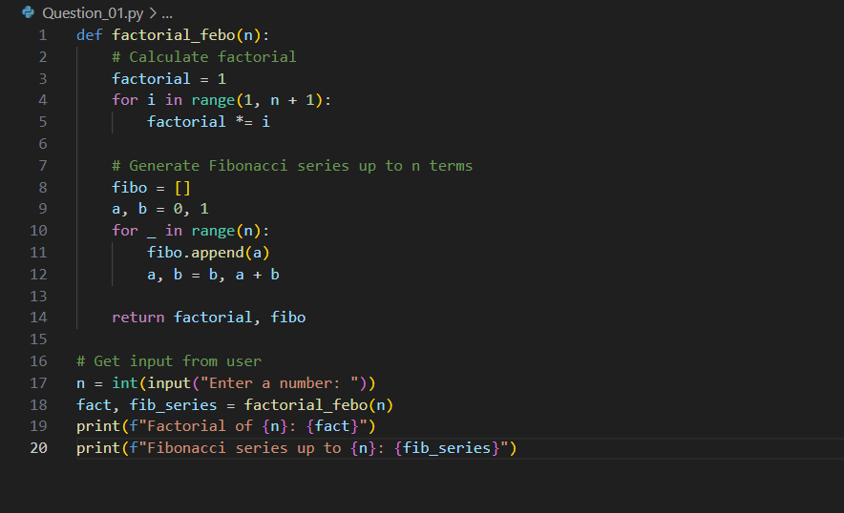
Output :

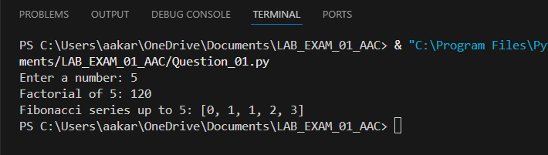

Prompt :

- Write python program for a function factorial_febo(n) that return both factorial of given number and Fibonacci series as per input “n” and I need to give the input values for fibonacci and factorial.

Explanation :

- factorial_febo(n): This function takes an integer n and calculates:
  - The factorial of n (product of all numbers from 1 to n).
  - The Fibonacci series up to n terms (starting from 0).
- factorial calculation:
  - Starts with factorial = 1.
  - Multiplies factorial by each number from 1 to n.
- Fibonacci series generation:
  - Initializes a = 0, b = 1.
  - Appends a to the list, then updates a and b for n terms.
- User input:
  - Prompts the user to enter a number.
  - Calls factorial_febo(n) with the input.
  - Prints the factorial and Fibonacci series.
This code lets the user enter a number and then displays its factorial and the Fibonacci sequence up to that number of terms.

